Chapter 7: Human Nutrition

7.1 Diet
A balanced diet is a diet that contains the proper proportions of carbohydrates, fats, proteins, vitamins, minerals, and water necessary to maintain good health.

Dietary Components
Nutrient | Principal Dietary Sources | Importance
Carbohydrates | Bread, cereals, pasta, rice, potatoes | Provide energy for metabolic processes.
Fats and Oils | Butter, margarine, cooking oils, nuts, fatty meats | Provide energy, act as an energy store, and provide insulation.
Proteins | Meat, fish, eggs, dairy products, beans, lentils | Needed for growth and repair of tissues, and to make enzymes.
Vitamin C | Citrus fruits, strawberries, green vegetables | Needed for the synthesis of collagen, which is important for healthy skin, gums, and blood vessels.
Vitamin D | Oily fish, eggs, liver, sunlight exposure on the skin | Needed for the absorption of calcium and for bone growth.
Calcium | Dairy products, leafy green vegetables, fortified foods | Needed for strong teeth and bones.
Iron | Red meat, liver, beans, nuts, dried fruits | Needed for the formation of hemoglobin in red blood cells, which transports oxygen around the body.
Fibre | Wholegrain cereals, fruits, vegetables | Adds bulk to food, aiding in the movement of food through the digestive system and preventing constipation.
Water | Drinks, fruits, vegetables | Essential for most bodily functions, including acting as a solvent for chemical reactions, and for transport of substances.

Deficiency Diseases
- Scurvy: Caused by a deficiency of Vitamin C. Symptoms include swollen and bleeding gums, and poor wound healing.
- Rickets: Caused by a deficiency of Vitamin D or calcium. It results in weak and soft bones, leading to bone deformities.
- Anaemia: Caused by a deficiency of iron.
- Constipation: Caused by a deficiency of fibre.

7.2 Digestive System

Organs of the Digestive System
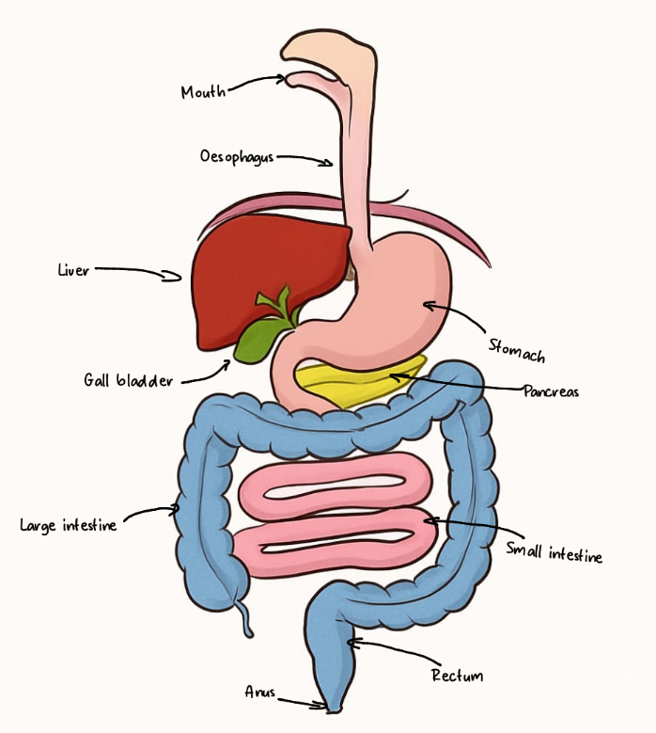
Alimentary Canal:
    - mouth
    - oesophagus
    - stomach
    - small intestine (duodenum and ileum)
    - large intestine (colon, rectum, anus)

Associated Organs:
- salivary glands
- pancreas
- liver
- gall bladder
Organ | Description
Alimentary Canal
Mouth | The first part of the digestive tract, where food is ingested and mechanical digestion (chewing) and chemical digestion (salivary amylase) begin.
Oesophagus | A muscular tube connecting the pharynx (throat) with the stomach. It transports food from the mouth to the stomach through peristalsis.
Stomach | An organ that stores food and mixes it with gastric juices (hydrochloric acid and pepsin) -forms chyme - to continue digestion, particularly of proteins.
Small Intestine | A long, coiled tube where most of the chemical digestion and absorption of nutrients occurs. It is divided into the duodenum and ileum.
—Duodenum | The first section of the small intestine, where chyme from the stomach is mixed with bile from the liver and pancreatic juice from the pancreas.
—Ileum | The final section of the small intestine, where the majority of nutrient absorption into the bloodstream takes place.
Large Intestine | The final section of the alimentary canal, responsible for absorbing water and electrolytes from the remaining indigestible food matter and then passing useless waste material from the body.
—Colon | The main part of the large intestine, which absorbs water and electrolytes from food that has remained undigested.
—Rectum | The concluding part of the large intestine that terminates in the anus. It stores fecal matter before it is expelled from the body.
—Anus | The external opening at the end of the digestive tract, through which feces are expelled.
Associated Organs
Salivary Glands | Glands that produce saliva, which moistens food and contains enzymes (like amylase) that begin the digestion of carbohydrates.
Pancreas | A gland that produces pancreatic juice (amylase, lipase, and protease) that break down carbohydrates, fats, and proteins. It also produces insulin.
Liver | A large organ that produces bile, which emulsifies fats, and plays a major role in metabolism, detoxification, and nutrient storage.
Gallbladder | A small organ that stores and concentrates bile produced by the liver, and releases it into the duodenum.

Functions of the Digestive System
- Ingestion: The taking of substances, e.g. food and drink, into the body through the mouth.
- Digestion: The breakdown food molecules.
- Absorption: The movement of nutrients (digested food molecules) through the wall of the intestine into the blood.
- Assimilation: The uptake and use of nutrients by cells.
- Egestion: The removal of undigested food from the body as faeces.

7.3 Physical Digestion
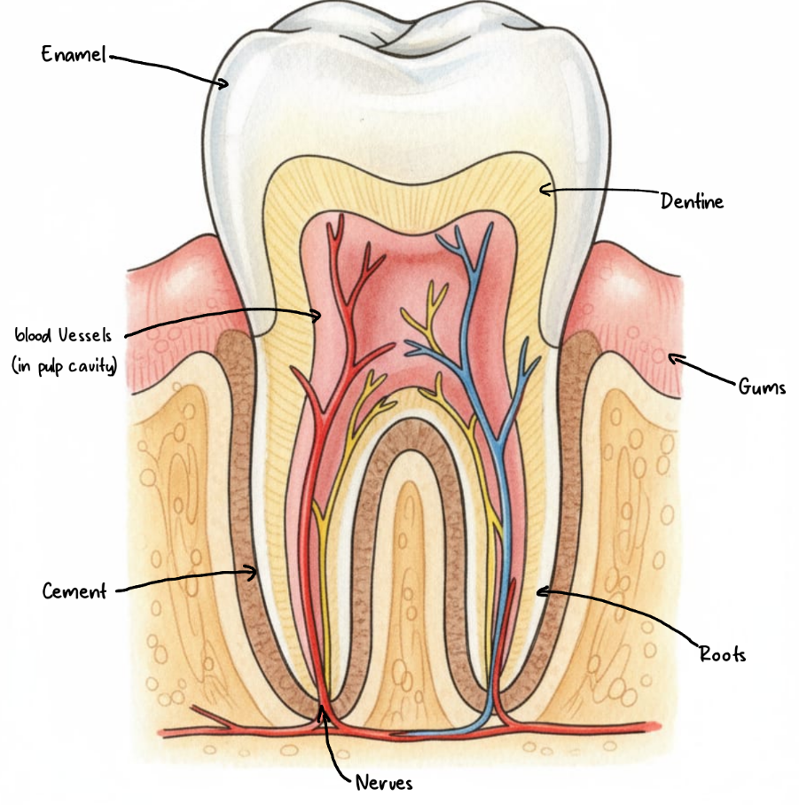
Physical digestion is the mechanical breakdown of food into smaller pieces without any chemical change. This increases the surface area of food for enzymes to act on, and increases the rate of chemical digestion..

- Teeth: Different types of teeth are adapted for different functions in physical digestion:
  - Incisors: Chisel-shaped teeth at the front of the mouth, used for biting and cutting.
  - Canines: Pointed teeth, used for tearing and ripping food.
  - Premolars and Molars: Broad, flat teeth at the back of the mouth, used for grinding, chewing, and crushing food.

Part | Description
Enamel | The hardest substance in the human body, covering the crown of the tooth. It protects the underlying dentine and pulp from damage.
Dentine | A bone-like tissue that makes up the bulk of the tooth. It is softer than enamel and contains microscopic tubules that transmit sensations to the pulp.
Pulp | The innermost part of the tooth, located in the pulp cavity. It contains nerves, blood vessels.
Nerves | Sensory fibers within the pulp that detect pain, temperature, and pressure.
Blood Vessels | Supply nutrients and oxygen to the pulp and remove waste products.
Cement | A bone-like tissue that covers the root of the tooth, helping to anchor it to the jawbone.
Bone | The jawbone in which the tooth is embedded, providing structural support.
Gums | The soft tissues that surround the base of the teeth, protecting the roots and supporting the teeth in the jawbone.

- Stomach: The muscular walls of the stomach churn and mix the food, breaking it down further.
- Bile: Produced by the liver and stored in the gall bladder, bile emulsifies fats, breaking down large fat globules into smaller droplets. This increases the surface area for lipase to act on.

7.4 Chemical Digestion
Chemical digestion is the breakdown of large, insoluble molecules into small, soluble molecules by the action of enzymes.

Digestive Enzymes
Enzyme | Secreted in | Acts in | Substrate | Product(s)
Amylase | Salivary glands, pancreas | Mouth, small intestine | Starch | Maltose (a simple sugar)
Maltase | Small intestine | Small intestine | Maltose | Glucose
Pepsin | Stomach | Stomach | Protein | Amino acids
Trypsin | Pancreas | Small intestine | Protein | Amino acids
Lipase | Pancreas | Small intestine | Fats and oils | Fatty acids and glycerol

Role of Hydrochloric Acid
Hydrochloric acid in the stomach has two main functions:

- It kills harmful microorganisms in food.
- It provides an acidic pH for the optimum activity of pepsin.

Role of Bile
Bile is an alkaline mixture that neutralizes the acidic mixture of food and gastric juices entering the duodenum from the stomach. This provides a suitable pH for the enzymes in the small intestine to work effectively.

7.5 Absorption
Absorption is the process by which small, soluble molecules are taken up from the small intestine into the bloodstream.

The Small Intestine and Villi
The small intestine is highly adapted for absorption. Its inner surface is folded into millions of tiny projections called villi, which in turn are covered in even smaller projections called microvilli. This structure vastly increases the surface area for absorption.

Each villus contains:

- A network of capillaries: Absorb most of the digested food molecules, such as glucose and amino acids.
- A lacteal: A small lymphatic vessel that absorbs digested fats (fatty acids and glycerol).
- A thin walls: short diffusion distance

Water Absorption
Most water is absorbed in the small intestine, but some is also absorbed in the colon.

